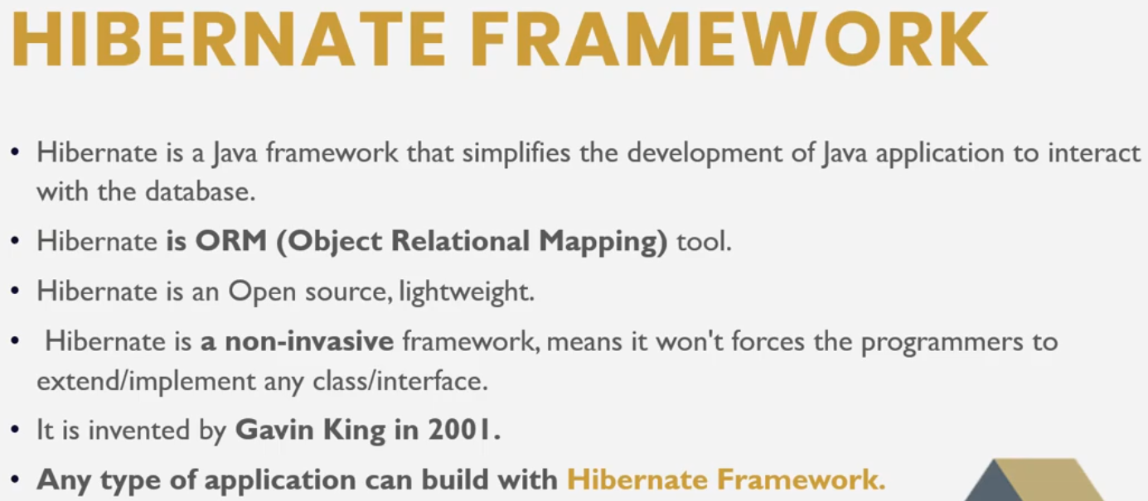

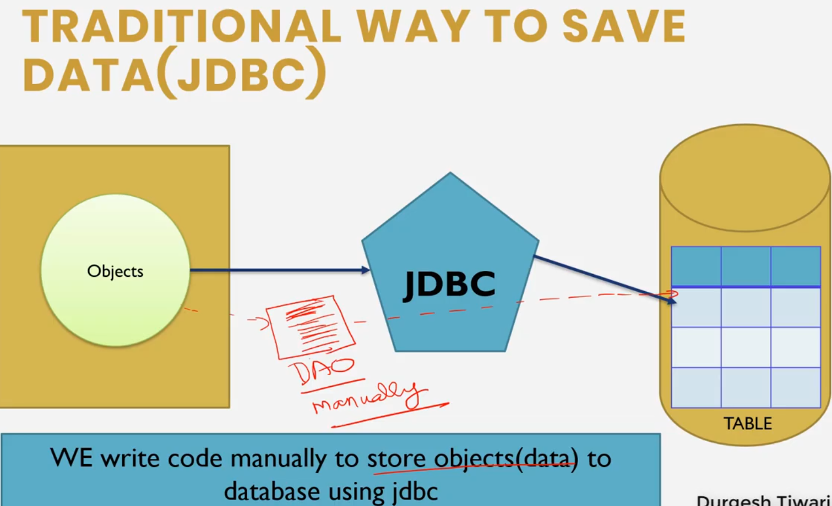

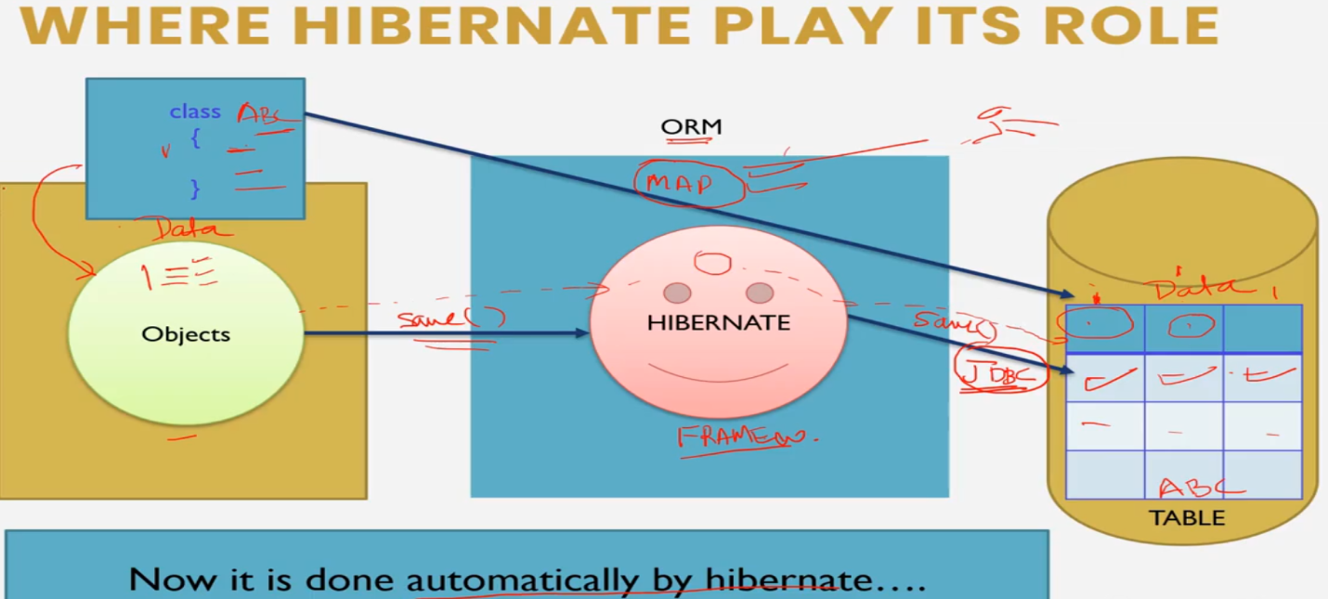

* Add Hibernate Core and Mysql Connector dependency in POM.xml

**Adding hibernate Configuration**

Right click on src/main/java add a xml fle hibernate.cfg.xml

Add the following dtd configuration file

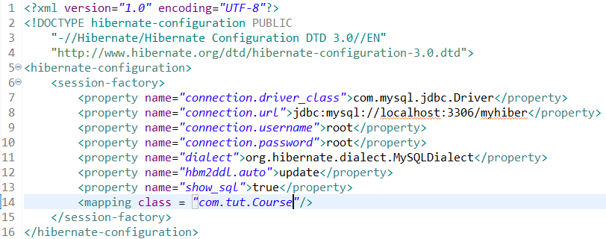

The dialect specifies the type of database used in hibernate

hbm2ddl.auto is a hibernate configuration property. It is used to validate and exports schema DDL to the database when the SessionFactory is created. Possible Values are “create”, “update”, “validate”, “create-drop”.

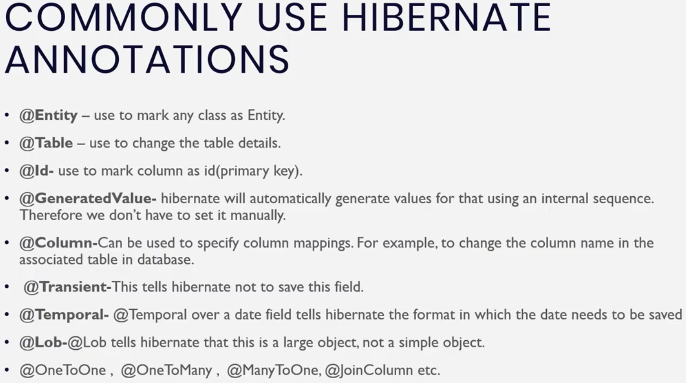

**Adding data including Image in database in Hibernate**

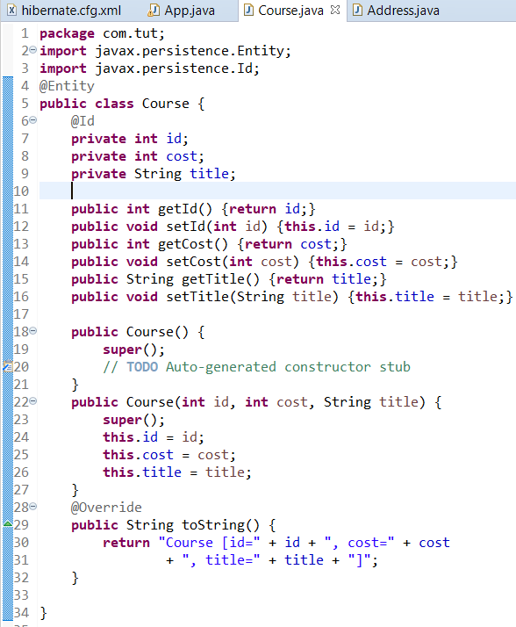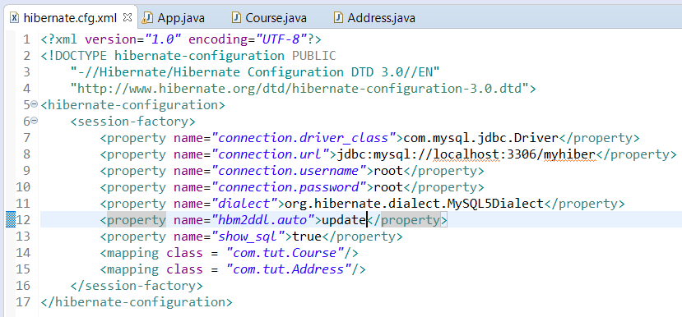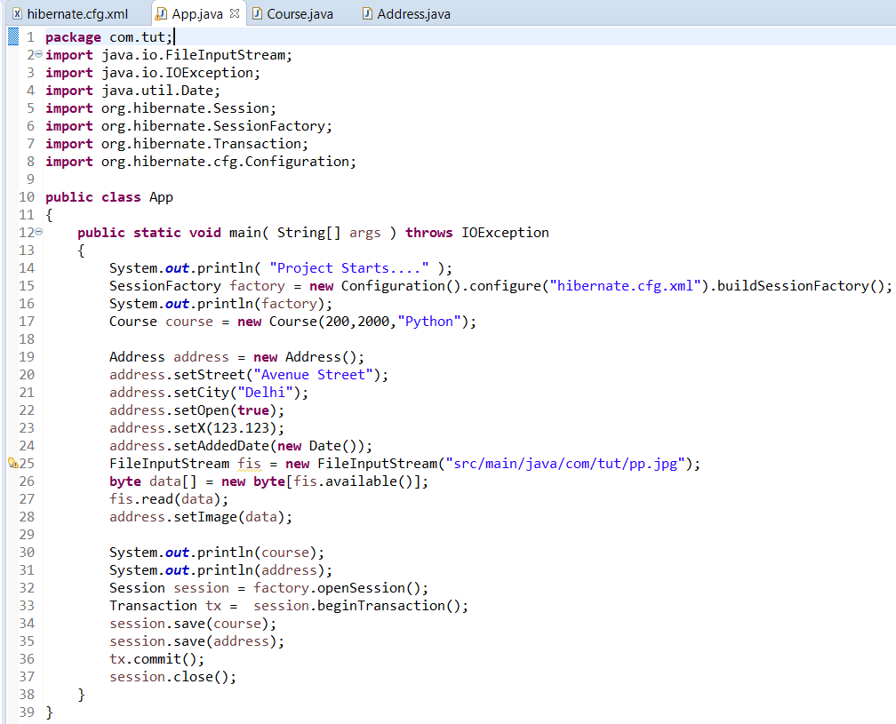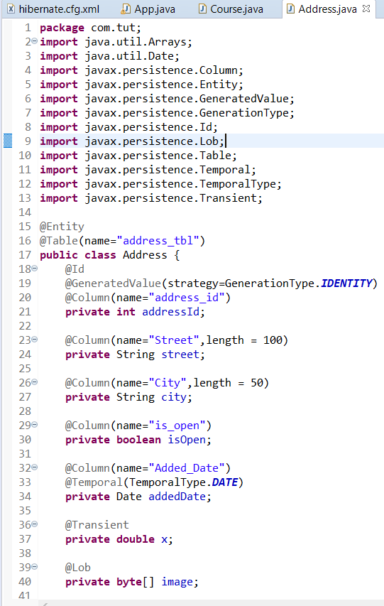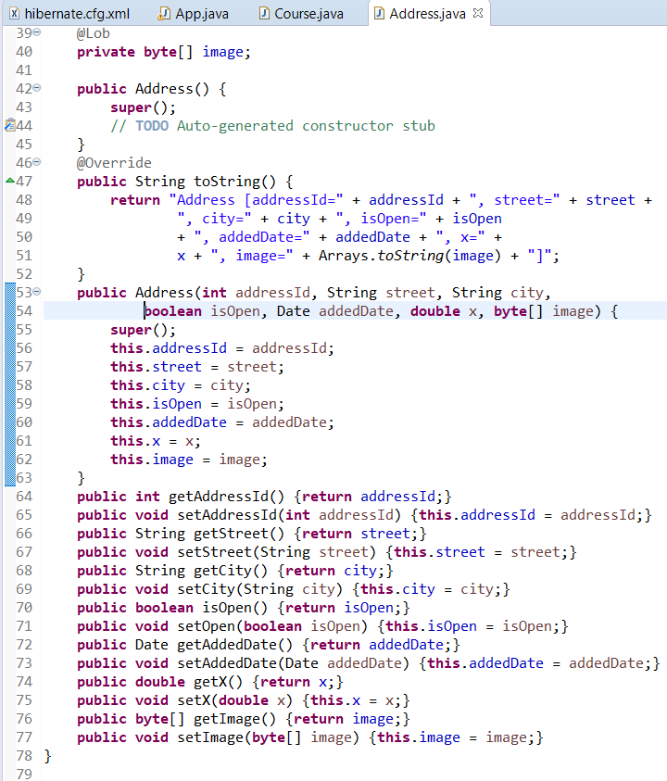

**FETCHING DATA using Hibernate.**

We can use any one of the get() method or load() method

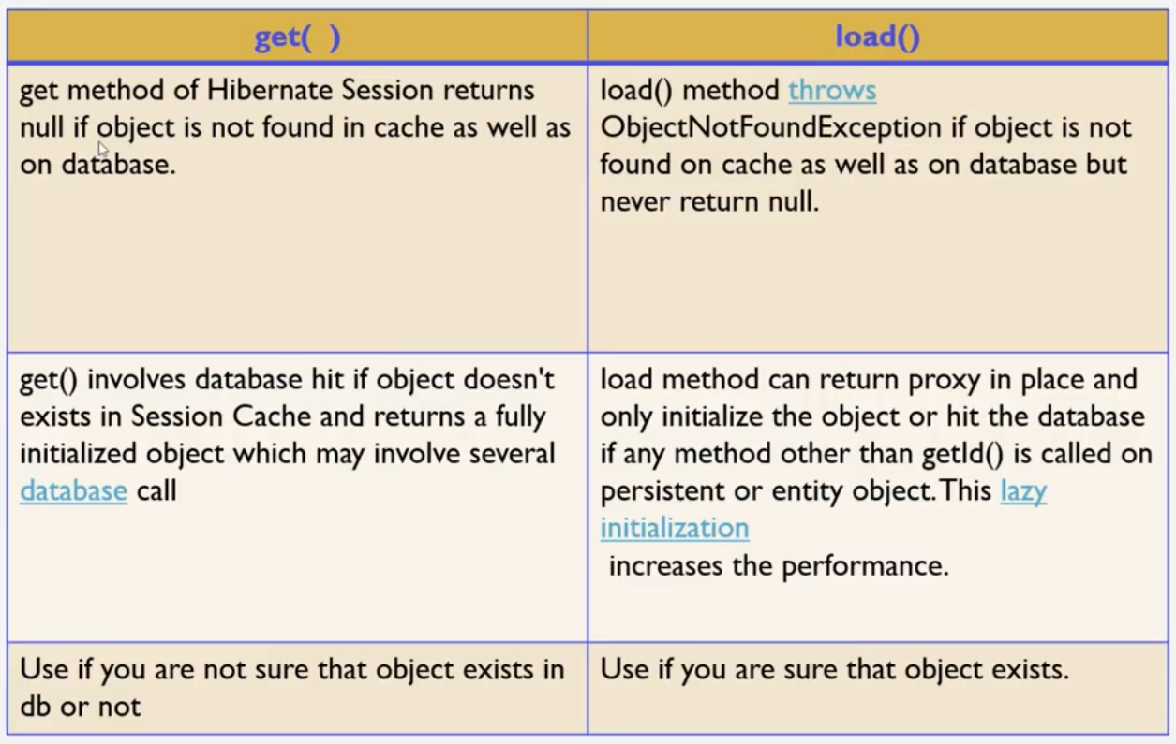

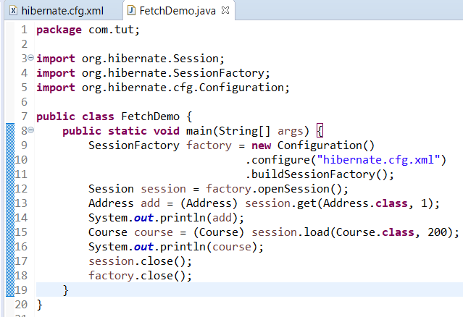

Hibernate.cfg.xml remains same in previous snapshot.

Example in video is different from Example actually implemented.

**@Embeddable in Hibernate**

@Embeddable annotation tells Hibernate and any other JPA implementation that a class and its mapping annotations can be embedded into an entity. Example in video differ from example implemented.

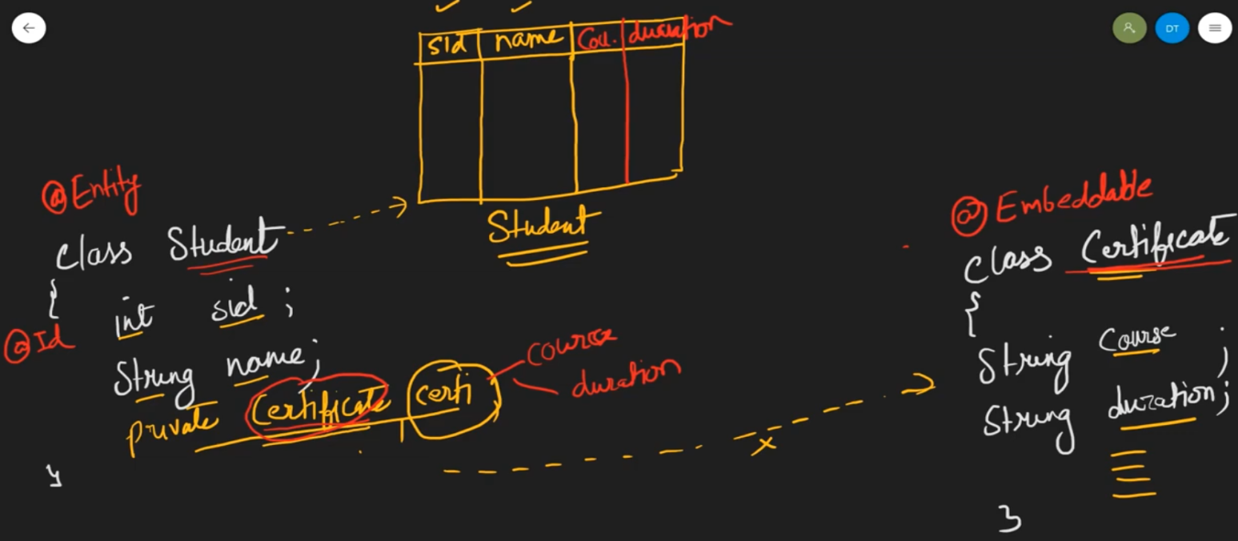

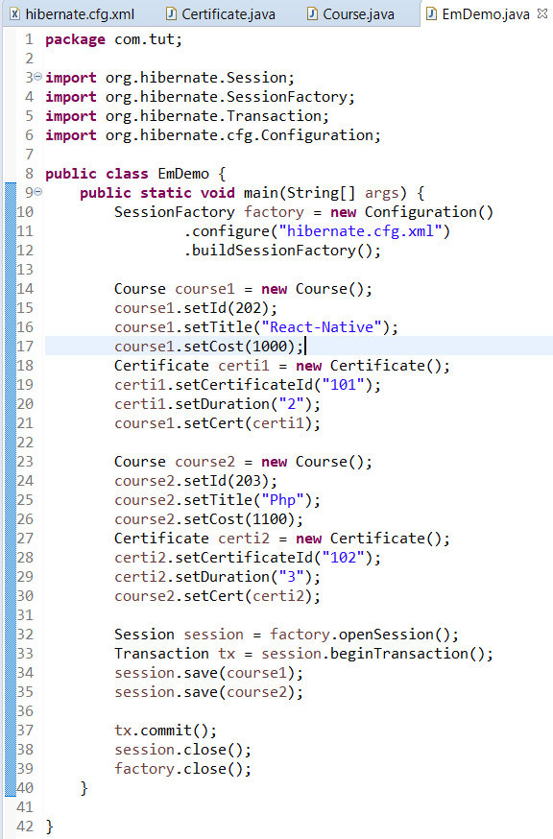

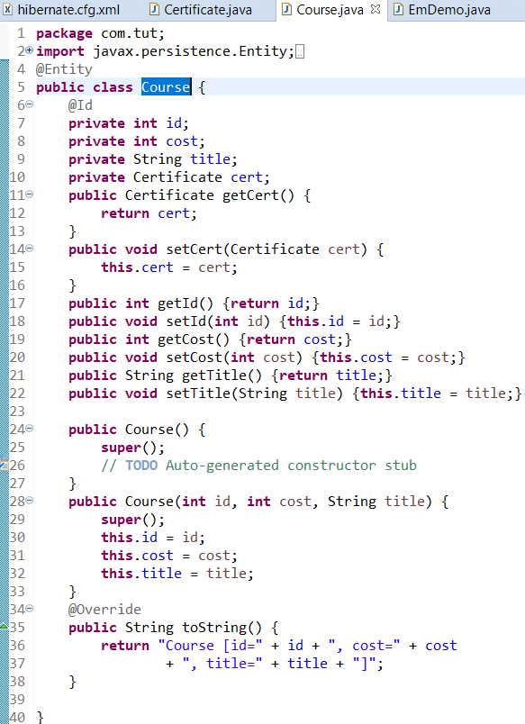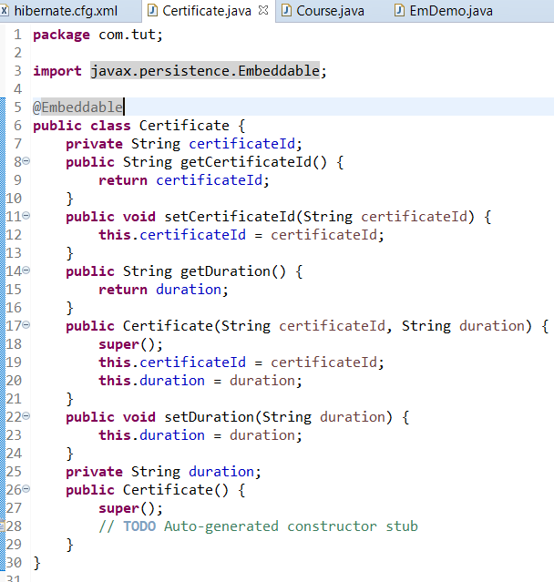

**OneToOne Mapping (uni-directional & bi-directional)**

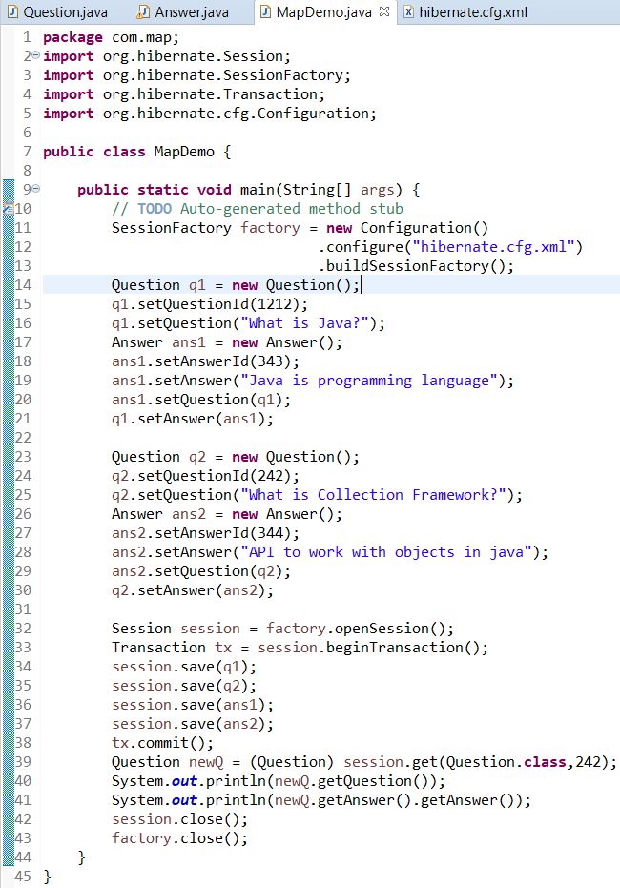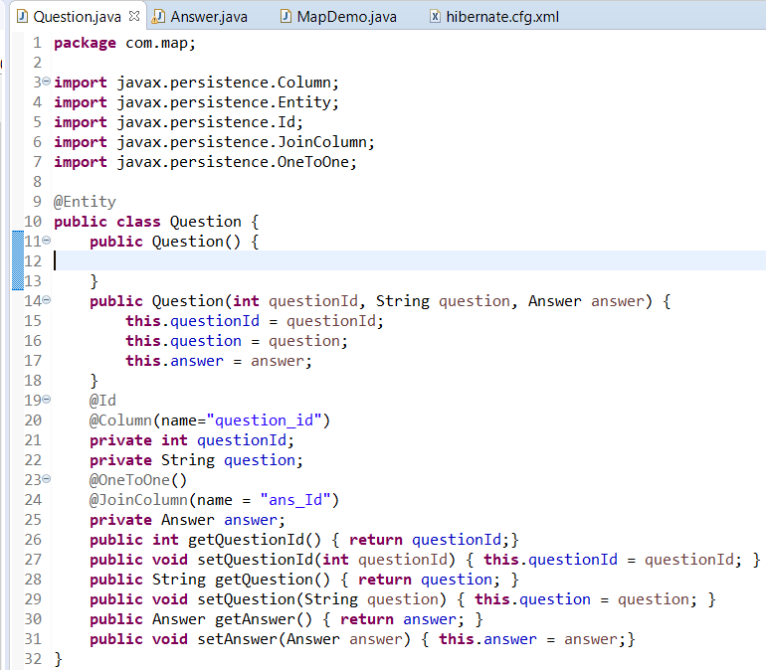

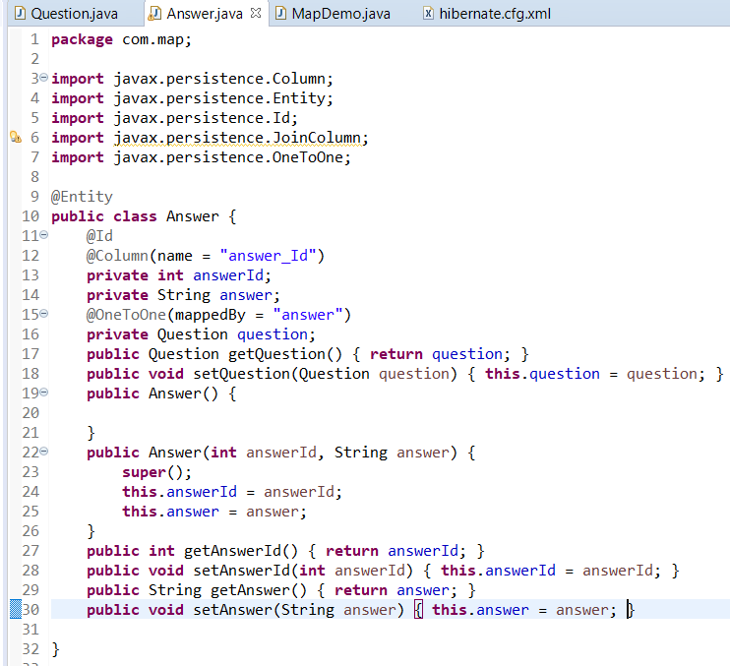

**@OneToMany Mapping**

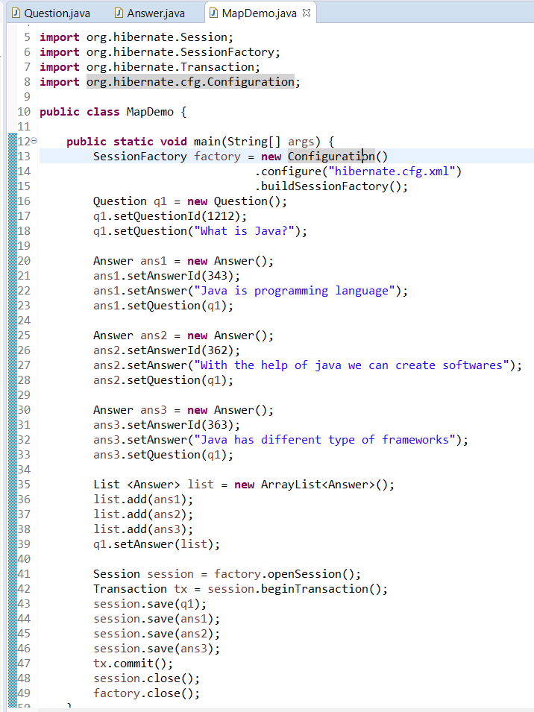

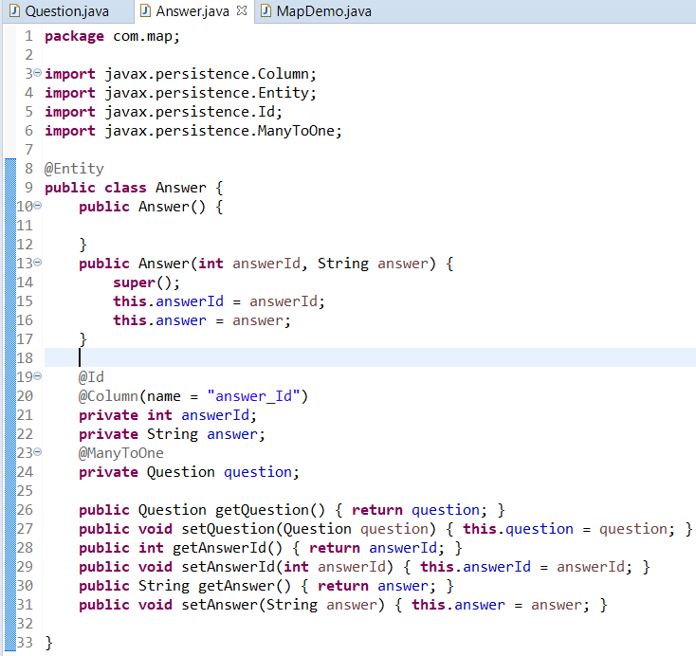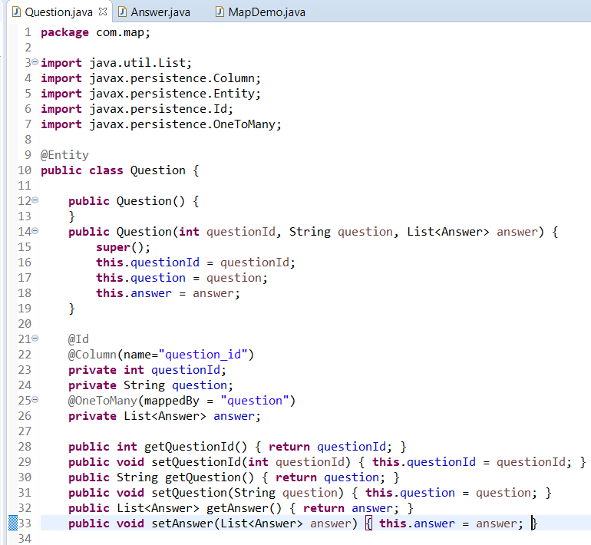

**@ManyToMany Mapping**

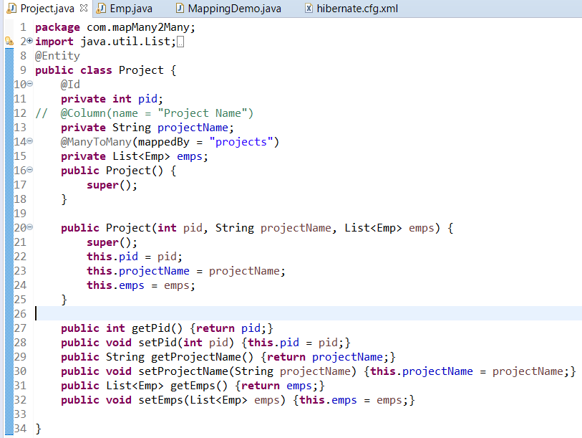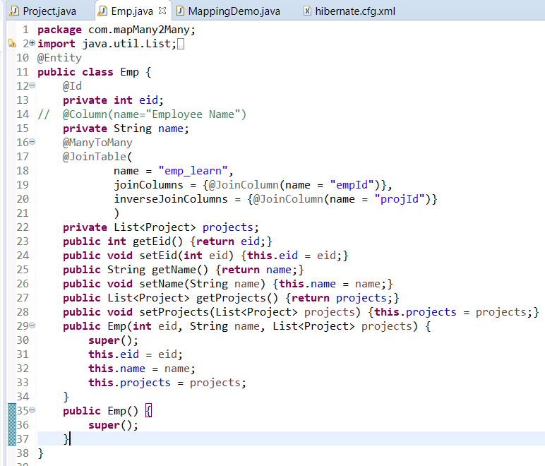

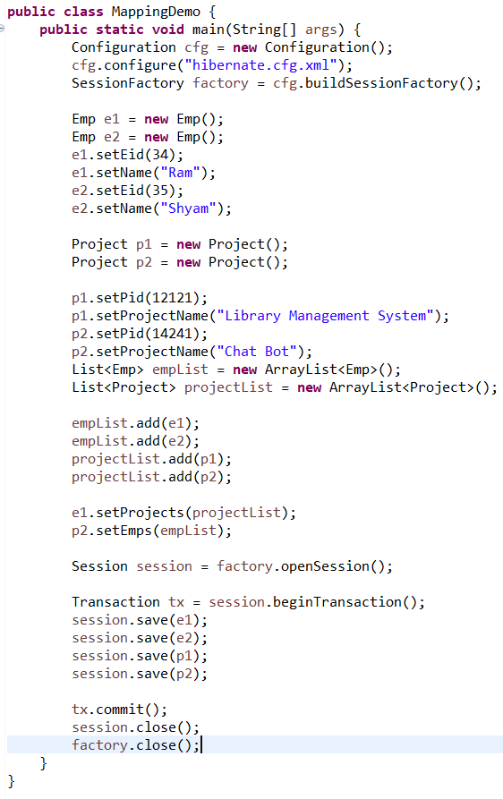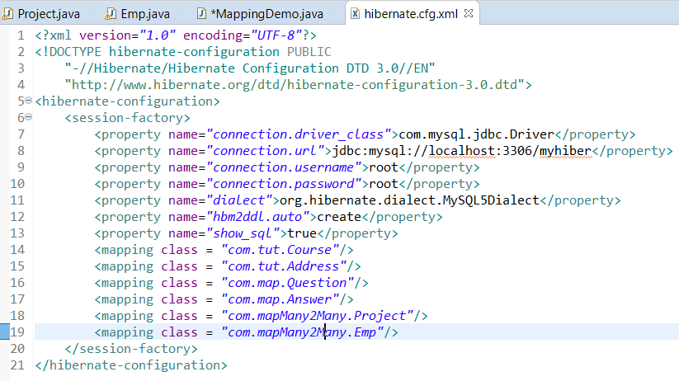

**Fetch Type In Hibernate**

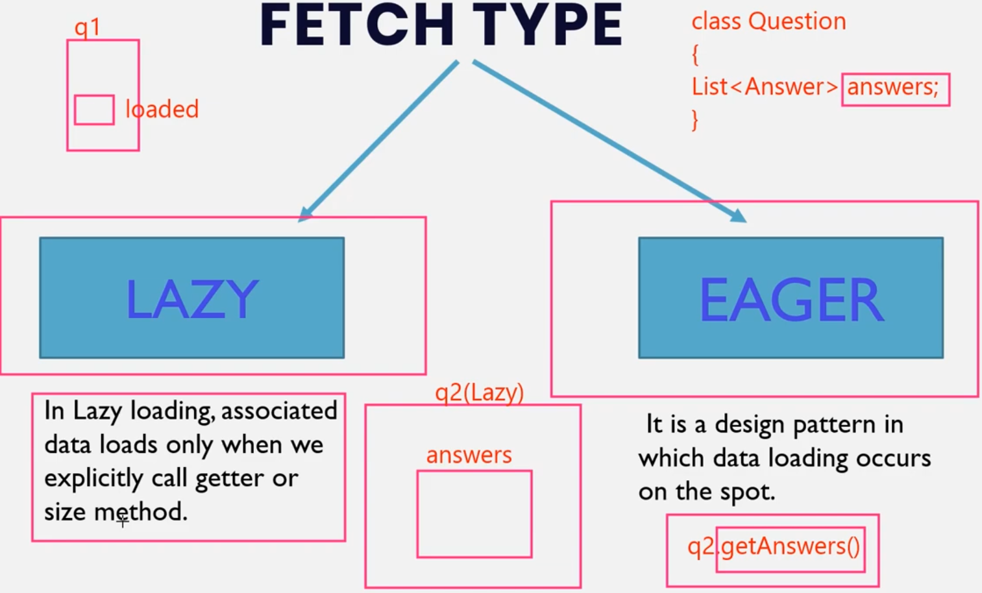

We will use the same example of ManyToOne Mapping

By default Lazy Loading is implemented. To use eager loading use

@OneToMany(mappedBy =”question”, fetch = FetchType.EAGER)

**Hibernate Object States (Persistence Life Cycle)**

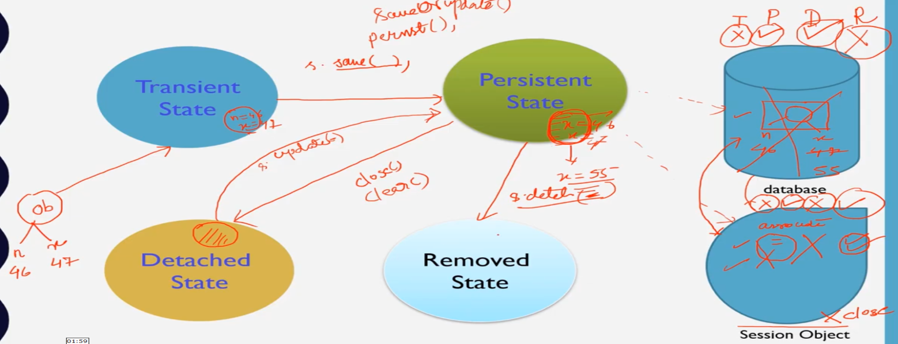

Practical session not implemented

**HQL(Hibernate Query Database)**

Fetching data from database

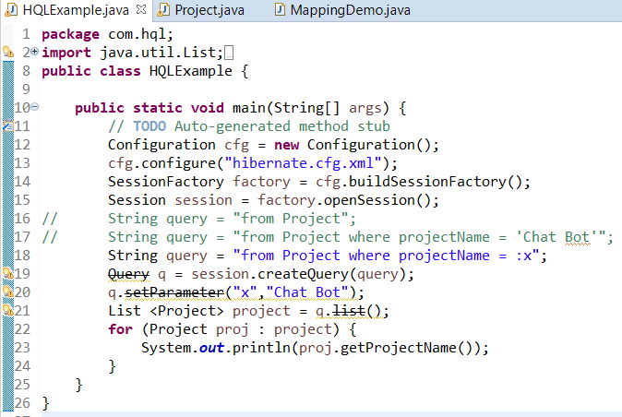

“Project” in line 16,17,18 is Name of Entity and “projectName” is the name of field in that entity.

**Update & Deleting data from database**

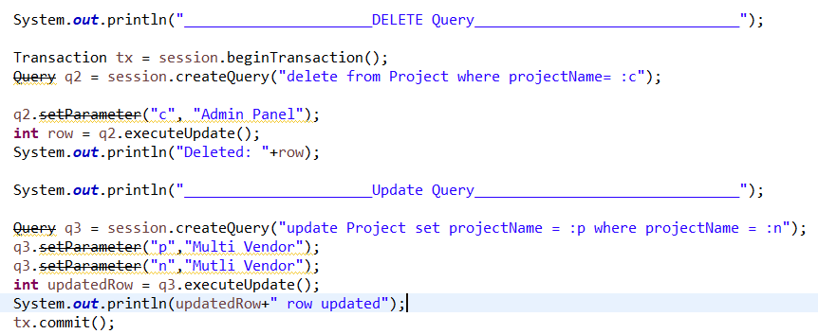

**Executing Join in Database**

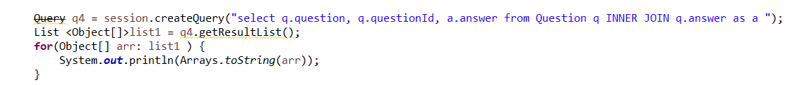

In above snapshots we have used a “Query” which is depricated. To update it we just need to update the package fro which wuery is being imported.

Simply we need to change

**import org.hibernate.*;** to

**import org.hibernate.query.\***;